Laws of Robotics

[Isaac Asimov](http://io9.com/50-years-ago-isaac-asimov-predicted-what-2014-would-lo-1493111283) devised his famous Three Laws of Robotics — a set of rules designed to ensure friendly robot behavior. Though intended as a literary device, these laws are heralded by some as a ready-made prescription for avoiding the robopocalypse. We spoke to the experts to find out if Asimov's safeguards have stood the test of time — and they haven't.

[](http://io9.com/50-years-ago-isaac-asimov-predicted-what-2014-would-lo-1493111283)

Fifty years ago, the 1964 World's Fair got Isaac Asimov to thinking about just what 2014 would

First, a quick overview of the Three Laws. As stated by Asimov in his **1942 short story "Runaround":**

**1. A robot may not injure a human being or, through inaction, allow a human being to come to harm.**

**2. A robot must obey the orders given to it by human beings, except where such orders would conflict with the First Law.**

**3. A robot must protect its own existence as long as such protection does not conflict with the First or Second Law.**

**Later, Asimov added a fourth, or zeroth law, that preceded the others in terms of priority:**

**0. A robot may not harm humanity, or, by inaction, allow humanity to come to harm.**

In Asimov's fictional universe, these laws were incorporated into nearly all of his "positronic" robots. They were not mere suggestions or guidelines — they were embedded into the software that governs their behavior. What's more, the rules could not be bypassed, over-written, or revised.

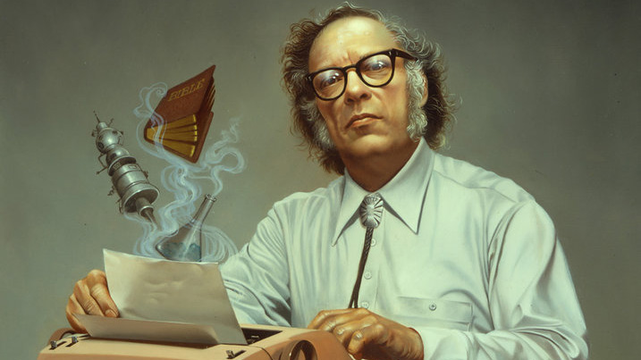[1](http://io9.com/ive-always-loved-the-smoke-rising-from-asimovs-ibm-sele-1553911250)

Invariably, and as demonstrated in so many of Asimov's novels, the imperfections, loopholes, and ambiguities enshrined within these laws often resulted in strange and counterintuitive robot behaviors. The laws were too vague, for example, by failing to properly define and distinguish "humans" and "robots." Additionally, robots could unknowingly breach the laws if information was kept from them. What's more, a robot or AI endowed with super-human intelligence would be hard-pressed to *not* figure out how to access and revise its core programming.

Isaac Asimov was born Isaak Yudovick Ozimov on January 2, 1920, in Petrovichi, Russia. The family immigrated to the United States when Asimov was a toddler, settling into the East New York section of Brooklyn. (Around this time, the family name was changed to Asimov.) Isaac Asimov became a biochemistry professor while pursuing writing. He published his first novel, Pebble in the Sky, in 1950. An immensely prolific author who penned nearly 500 books, he published influential sci-fi works like I, Robot and the Foundation trilogy, as well as books in a variety of other genres. Asimov died in New York City on April 6, 1992.

